Interacoustics Press Release
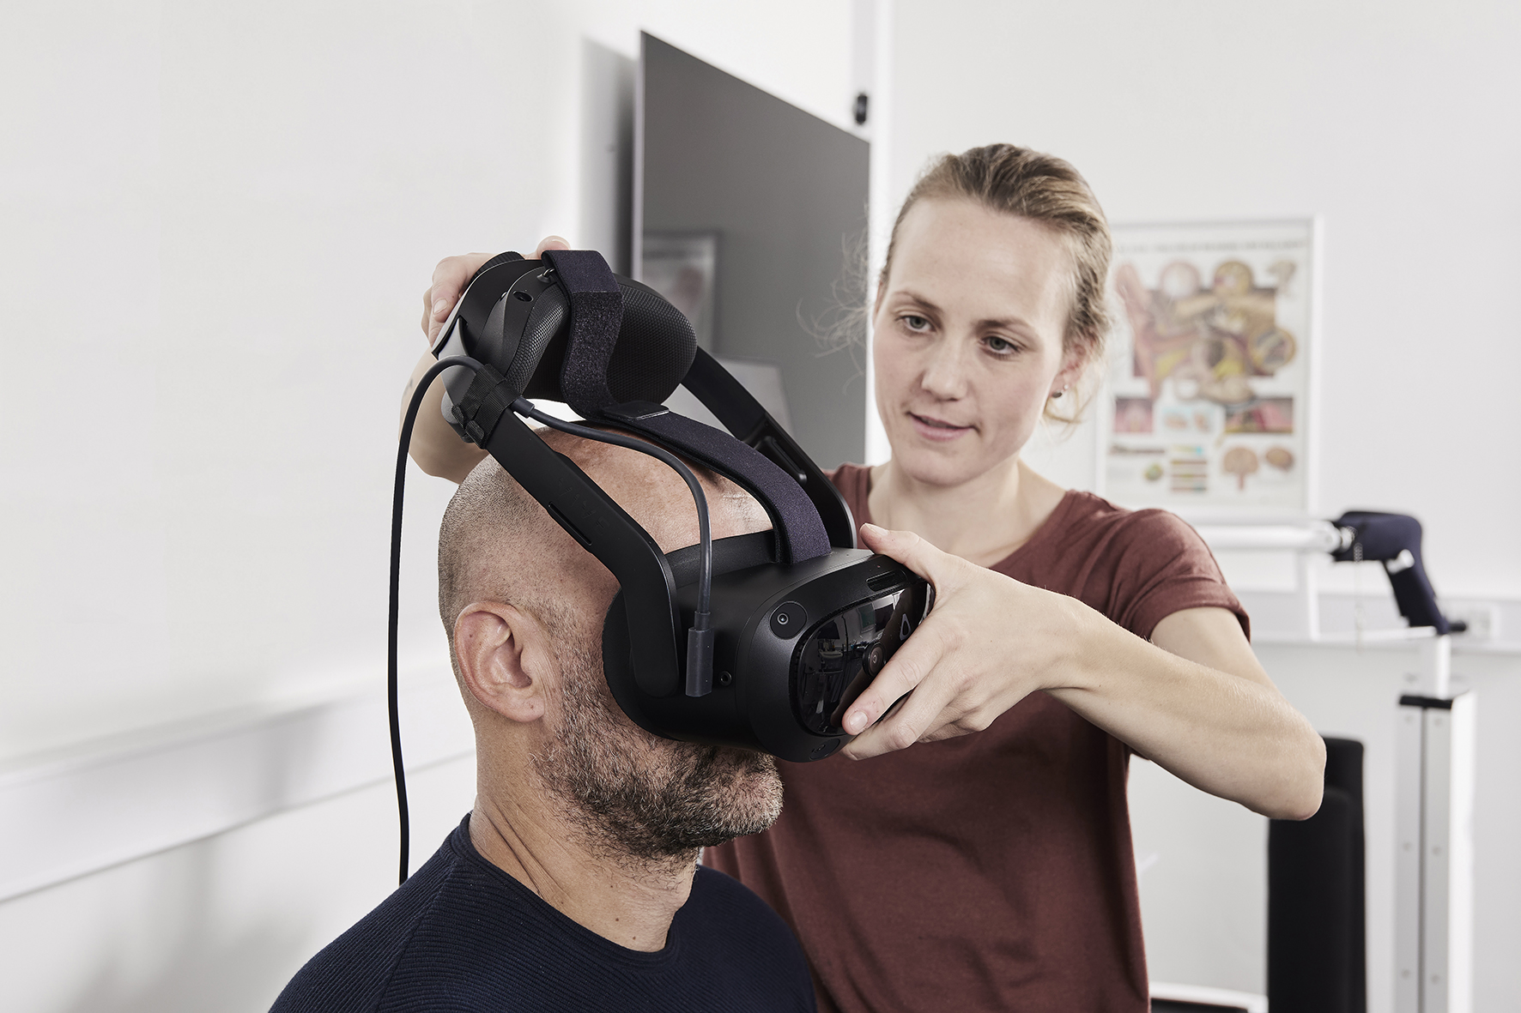

Interacoustics introduces new VR headset for their Virtualis solutions

Interacoustics is excited to announce the launch of its new Virtualis VR headset: a headset designed to support comprehensive rehabilitation across balance, vestibular, neurological, and musculoskeletal needs.
The headset combines high-resolution, advanced graphics with rehabilitation technology that provides personalized, efficient, and motivating patient care. It supports both wired and wireless use and can also be used in a portable set-up depending on the need. Using the wireless option, patients can move around freely without any restrictions.
Its lightweight design ensures quick positioning and a comfortable fit, while precise eye adjustment enhances visual clarity. A built‑in motion sensor enables accurate, objective functional assessments to track patient progress.
Fully compatible with all Virtualis solutions, the Virtualis VR headset empowers clinicians to offer immersive, evidence-based rehabilitation experiences that fit seamlessly into their workflows.
Read more about the new VR headset and Virtualis rehabilitation solutions on the Interacoustics website.
Worldwide:
www.interacoustics.com
info@interacoustics.com

